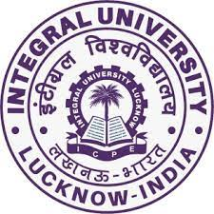

**Integral University, Lucknow**

**Department of Chemistry and Department of Environmental Sciences**

**Organize**

**Awareness Program**

**On**

**Health and Hygiene Practices: Relevance in the current Pandemic Era**

**Date: 12th April 2022**

**Report**

Keeping in mind the present ongoing COVID-19 pandemic and to spread awareness about the importance of health and hygiene, and to commemorate ‘World Heath Day’ (7th April), amongst the nearby localities, the Department of Chemistry and Department of Environmental Sciences, Integral University, Lucknow organised, an awareness program for the students of Mega Academy, Asti Village, Bakshi Ka Talab, Lucknow on 12th April 2022 from 10:00 am onwards. The activity was also planned to promote the **Sustainable Development Goal (SDG) 3** **on Good Health and Wellbeing**. For sustainable development it is essential to ensure the well-being of all. The students of the participating departments under the guidance of Dr. Tahmeena Khan, Assistant Professor, Department of Chemistry and Dr. Anand Mishra, Department of Environmental Sciences, Integral University prepared informative and attractive posters to educate the children about the importance of hygiene practices and sanitary habits. Many informative tips for keeping good health and hygiene were given. Children were prompted to share their usual daily hygiene practices. Children were also told the importance of eating healthy and nutritious food, keeping their bodies healthy inside, fighting diseases and boosting their immunity. Children were further motivated to share the things learnt during the program with their family members. Several other faculty members namely Dr. Naseem Ahmad, Dr. Daraksha Bano and Dr. Iqbal Azad also accompanied and keenly participated in the activity. Overall, the program was very informative and well-attended.

**Glimpses of the event**

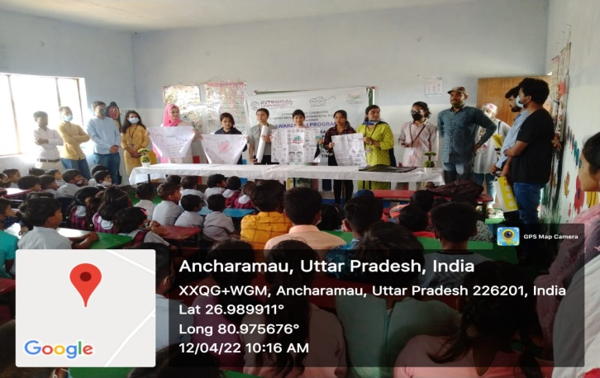 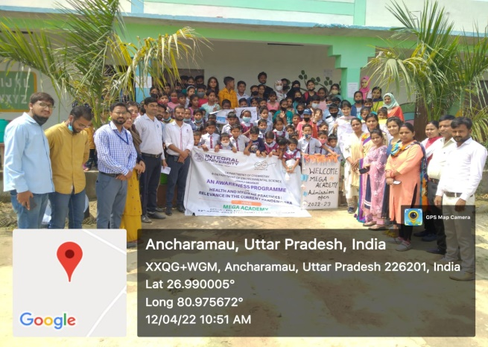 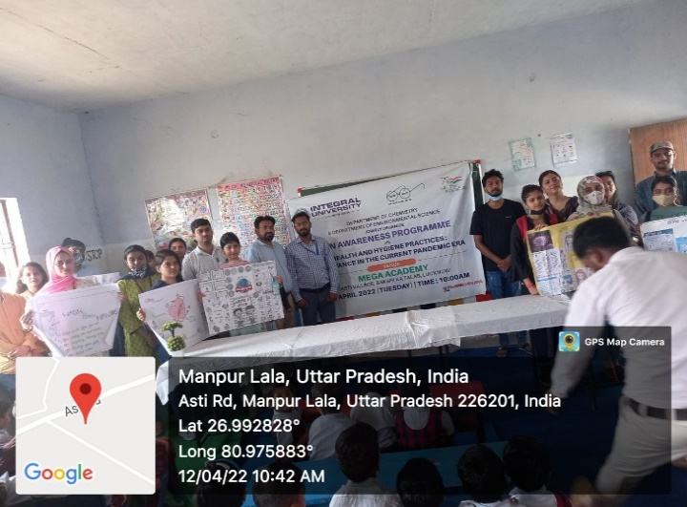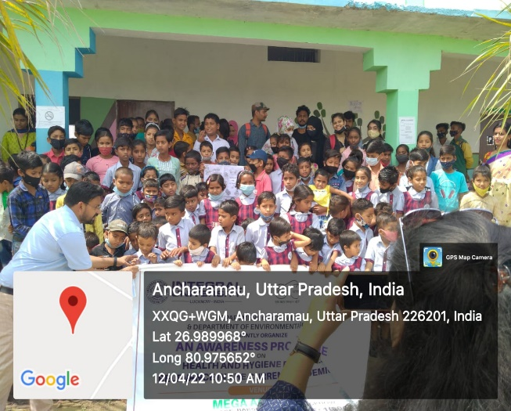

Respectfully Submitted by:

Faculty Coordinators

Dr. Tahmeena Khan

Dr. Anand Mishra